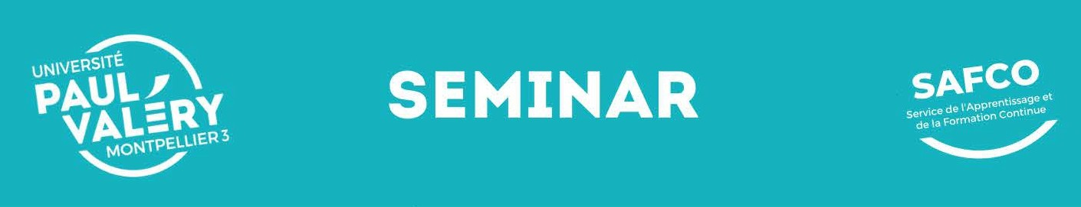
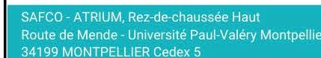
@ PUBLIC
Gratuated music therapists
Neurologists Neuropsychologists

PRE-REQUIREMENTS
- Music Therapy Degree
(Master, Bachelor, Professional Certificate)
- Neurologists PhD
- Neuropsychologists

:o SHORTLIST
This seminar is for professionals only.
Minimal number : 35 trainees Maximum number: 50 trainees

&\ TEACHING STAFF
WORLD-RENOWNED EXPERTS

Dr. Corene P. HURT-THAUT
Dr. Michael H. THAUT

(9 DURATION
Preparatory and personal work :
6 hours of mandatory self-training (online videos and test)

34 HOURS OF SEMINAR

fill::] DATES ET TIMES
JULY 2024
I I

@ RATES
Classroom seminar
  - Employer-funded training : 1700 €
  - Self-funded training : 1200 €
Preparation and passing of the certificate of
The International Training Institute in Neurologic Music Therapy

OBJECTIVES
This seminar is part of professional Education organized at Paul-Valery Montpellier 3 University to provide a complementary training to graduated music therapists, neuropsychologists and neurologists.

Neurologic Music Therapy (NMT) is defined as the therapeutic application of music to cognitique, sensory and motor function due to neurologic disease of the human nervous system.Its treatment techniques are based on the scientific knowledge in music perception and production and the effects thereof on non-musical brain and behavior functions. Populations served by Neurologic Music Therapists include, but are not limited to: stroke, traumatic brain injury, Parkinson's and Huntington's disease, cerebral palsy, Alzheimer's disease, autism, and other neurological diseases affecting cognition, movement, and communication (e.g., MS, MuscularDystrophy,etc).
The 34-hours program will provide 36 CMTE credits approved by US Certification Board of MusicTherapy.
A certificate of completion can be submitted as proof of attendance and participation.

PROGRAM
- Scientific Foundations of NMT Neuropathology/ Disease Review
- Sensorimotor Techniques : Rhythmic Auditory Stimulation, Pattern Sensory Enhancement, Therapeutic Instrumental Playing,
- Speech Techniques : Melodic Intonation Therapy, Musical Speech Stimulation, Rhythmic Speech Cueing, Vocal Intonation Therapy, Therapeutic Singing, Oral Motor and Respiratory Exercises, Developmental Speech and Language Training through Music, Symbolic Communication Training through Music,
- Cognitive Techniques : Music Neglect Training, Auditory perception Training, Musical Attention Control Training, Musical Mnemonics Training, Associative Mood and Memory Training, Musical Executive Functions Training, Music Psychosocial Training,

LOCATION
Paul-Valery Montpellier 3 University - Saint-Louis Site 11 rue Saint-Louis, 34000 MONTPELLIER (France)

CONTACTS
Educational Manager : Mrs Amelie LESAGE DE LA HAYE

Information and application : Mrs Laure LAPEYRE musicotheraRie@univ-montR3.fr +33 (0)4 67 06 07 78
Monday 1 | Tuesday 2 | Wednesday 3 | Thursday 4
8:30AM - 6PM | 9AM - 6PM | 9AM -6PM | 9AM-2:45PM

Quotation and invoicing : Mrs Charlotte AUGUSTE modules.musico.fc@univ-montr.i3.fr +33 (0)4 67 14 55 70

APPLICATION
Send the application form to musicotheraRie@univ-montR3.fr Deadline is set to a maximum of 30 days before seminar's start
.• -

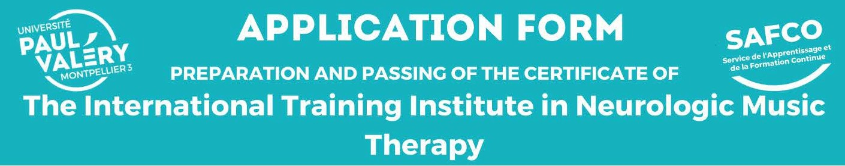
Teaching Staff: Dr.Michael H. THAUT/ Dr.Corene P. HURT-THAUT

Organized by Paul-Valery Montpellier 3 University Music Therapy Education Department
in partnership with TheAcademy of Neurologic Music Therapy
https://nmtacademy.co/

SCHEDULE

PreRaratory and Rersonal work:
0
6 hours of mandatory self-formation (online videos and test)
To do before the seminary

I JULY 2024 I
Monday 1 | Tuesday 2 | Wednesday 3 | Thursday 4
8:30AM-6PM | 9AM-6PM | 9AM- 6PM | 9AM- 2:45PM

INFORMATIONS ABOUT THE TRAINEE

SURNAME: ............................................... First name: ........................................... Nationality: .....................................
City of birth:........................................................................... Date of birth:........ /........ /........
E-mail : ......................................................................................................... Phone: .............................................................
Adress • .................................................................................................................................................................................................
Degree(s) • .........................................................................................................................................................................................
Company/institution:......................................................................................... Job:.............................................................
MOTIVATION Please explain (manimum 5 lines) your motivations to participate to this training.

CONSENT
I give my consent to the University's registering my name and e-mail

FUNDING
Funded training: D Employer-funded training (1700€)

adress in its list and to my receiving information by mail [l] :
D YES
NO
□
D Self-funded training (1200€)

I agree to be photographed during this training : DYES D NO

CONTACTS
Information and application: MrsLaure LAPEYRE
C8:J musicotheragie@univ-montQ3.fr
Quotation and funding : MrsCharlotte AUGUSTE
C8:] modules.musico.fc@univ-montg3.fr

DOCUMENTS TO SEND
musicothera12ie@univ-mont123.fr
Filled and signed application form Curriculum Vitae Degree(s) copy(ies)

Date: TRAINEE'S SIGNATURE:

RESERVED FOR THE L'ADMINISTRATION
Candidature re ue le:.............................. Avis de la commission : Financement: Externe (employeur. OPCO....) lndividuel

OUI NON

Nom du responsable: .................................... Date : Signature:
[l] Thetrainee is informed that in accordance with data protection and freedom of inforniation laws, he/she has the right to access, rectify, oppose and delete the data concerning him/her.

